INTERNSHIP REPORT ON **“WEB DEVELOPMENT”**

**Submitted to Bengaluru City University**

**In partial fulfilment for the award of B.C.A Degree**

**By**

**SHOAIB KHAN**

**Department of Computer Science**

# COLLEGE CERTIFICATE

This is to certify that the internship report on “**WEB DEVELOPMENT**” is carried out by **SHOAIB KHAN**S tudent of VI Semester BCA, bearing has successfully completed his 7 weeks organisational study.

The Internship report is submitted to the Bengaluru City University in the Academic Year 2023-24, in partial fulfilment for successful completion of VI semester B.C.A and award of Bachelor of Computer Science Degree of Bengaluru City University.

Place: Bengaluru PRINCIPAL Date:

# DECLARATION BY STUDENT

I hereby declare that this Internship report on “WEB DEVELOPMENT” is an original record of my experience while conducting the internship study at PRINSTON SMART ENGINEERS.

The organizational study was carried out by me, in partial fulfilment for the successful completion of VI semester B.C.A of Bengaluru City University. This report is not submitted to any other university for the award of any Diploma/Degree etc.

**TABLE OF CONTENT**

## Chapters

1. Company Profile
2. About the company
   1. History
   2. Skill development & Training
   3. Importance of Non-Profit Internship
   4. Mission and Vision
   5. About Prinston Smart Engineers
   6. Internship Website
3. Objective of Organisation
   1. Product/Services by Prinston Smart Engineer:
   2. Organisation Mission
4. Scope and Objective of Internship
   1. Full Stack Development-An Overview
   2. Training Program
   3. Work Culture
   4. Scope of Internship
5. Introduction
   1. XAMPP
   2. MYSQL
   3. PHP
   4. HTML
   5. CSS
6. Outcome of Internship Program
7. Assignment Based on Internship
8. Output Screenshot
9. Annexures
10. Internship Attendance Certificate
11. LogSheet
12. Bibliography
13. Conclusion

**CHAPTER 1:**

# COMPANY PROFILE

**NAME PRINSTON SMART ENGINEERS**

**Contact Number +91 98101 88747**

**E-Mail Prinston.Smart@gmail.com.**

**Type of the Company Private**

**Nature of the Company Internship Opportunities**

**Industry Education Technology (EdTech),**

**Professional Development**

**Company logo**

**Vision To be the leading global platform for internship opportunities, fostering a community where students can grow professionally, companies can find emerging talent, and educational institutions can ensure their students are career- Ready.**

**CHAPTER 2:**

# ABOUT THE COMPANY

## Prinston Smart Engineers

**SMART ENGINEERS** trace its roots back to 2004 in New Delhi and since then have never looked back. With Dozens of successful projects under our belt, we can proudly say that we are one of the most trusted Engineering, Maintenance Training Services in Delhi.

For more than 13 years, Smart Engineers has offered a wide range of Maintenance & Services in Delhi, many other cities of India We strive to maintain the highest standards while exceeding client’s expectations at all levels. We not only honour commitments, but are known for meeting tough deadlines while delivering nothing but the best. We aim to create a responsive client relationship that allows us to meet and even exceed the goals of each of our projects.

**HISTORY**

Smart Engineers is well known for its innovation and by collaborating successfully with our customers, designers, sub-contractors, consultants as well as suppliers; we have been able to provide more specialized level of services. We are continuously evolving and understand the different aspects of delivering high value construction and complex projects with ease.

PRINSTON SMART ENGINEERS is an ISO 9001:2015 certified training division specializing in effective training of B.Tech, Diploma and Computer science students. We have trained 30000+ Students for science

& Technology program in various schools and various TECHNICAL CERTIFICATIONS FOR ENGINEERING STUDENTS. Courses are designed to cover all aspects of most of our real projects over the years to provide for smooth transfer of REAL knowledge and expertise that we have gained over the years. Training is HANDS-ON and covers all required fundamental and specialist know-how in system operation, troubleshooting & maintenance, designing and installation. Our program is basically designed to minimize the gap between industrial demands and young engineers. Prinston Smart Engineers is a Mechanical, Electrical, And IT Service Company, we design, build, construct, supply, install, service and upgrade of Electro-Mechanical Systems & Networks, Utilities and Equipment. Our scope covers Engineering, Documentation, Submittals Approval, Shop drawings, Coordinating Drawings, Commissioning, Start-Up, As-Built ACC. To Contract Programs, Project Time Schedules – Complying Consultant Specifications, as well as IT services and provides a platform for engineering students to learn industry skills by providing live instructor-led interactive online training.

For more than 13 years, Smart Engineers has offered a wide range of Maintenance & Services in Delhi, many other cities of India we strive to maintain the highest standards while exceeding client’s expectations at all level. we aim to create a responsive client relationship that allows us to meet and even exceed the goals of each of our projects. In 2016 we expanded our services in Skill development and Training program

for Engineering students in different domain. India today produce 1.5 million Engineering graduate a year, it is however agreed by all that 75% of these graduates are unemployed, agreeing to the fact that there is need to provide Skill training to the Engineering students. In 2018 when AICTE announced that internship is mandatory for engineering students to ensure that technical students get exposure to the industrial environment, current technology relevant to their subject and opportunities to learn understand and sharpen real time technical and managerial skills.

**SKILL DEVELOPMENT & TRAINING**:

Today industry demands more than just knowledge we are here to train young engineers and non-engineers to develop and strengthen their technical and professional skills.

**Importance of Non-Profit Internships**:

Non-profit internships occupy a vital space in the professional development arena. Unlike traditional internships, non-profit organizations like Prinston Smart Engineers prioritize the personal and professional growth of individuals over financial gains. This approach allows interns to immerse themselves in projects aligned with their passions and long-term career goals, fostering a sense of purpose and fulfilment.

**Mission and Vision**:

At the heart of the industry Prinston Smart Engineers mission to guide individuals on a journey towards their dreams. The company's commitment to non-profit initiatives underscores its dedication to making a positive impact on the lives of interns, emphasizing personal and professional growth without the constraints of financial objectives.Prinston Smart Engineers envisions a future where internships become transformative experiences that go beyond the ordinary, creating a ripple effect of empowered individuals contributing meaningfully to their respective fields.

**About Us:**

Prinston Smart Engineers is a privately held company with a mission to revolutionize the way knowledge is disseminated and utilized in the IT industry. Our team, consisting of 11-50 passionate and skilled professionals, is driven by a collective vision of empowering individuals with the tools and insights necessary to excel in the ever-evolving landscape of Information Technology. Learning Outcomes: The hands-on nature of the internship allowed for the practical application of theoretical knowledge. From refining coding practices to understanding the intricacies of GUI development, the experience offered a holistic understanding of software development processes. Additionally, collaborating with mentors and peers facilitated knowledge exchange, exposing interns to various coding styles, problem-solving approaches, and industry best practices. Our Commitment to Knowledge: At the core of our philosophy is the belief that knowledge is a catalyst for positive change. We have strategically positioned ourselves leaders in IT Services and Consulting, aiming to bridge the gap between theory and application. Through our innovative approaches to learning, we empower professionals and enthusiasts alike to stay at the forefront of technological advancements. Key Initiatives: Internship Programs: We take pride in offering dynamic internship programs that provide hands-on experience and mentorship, ensuring that participants are well-prepared for the demands of the IT industry. Consulting Services: Our seasoned experts offer IT consulting services tailored to meet the unique needs of businesses, leveraging cutting-edge technologies and strategic insights to drive success. The impact of a dream-focused internship extends beyond the immediate learning experience. It lays the groundwork for future career success by instilling a sense of purpose, honing essential skills, and fostering a proactive approach to professional growth. As the industry continues to innovate, individuals with non-profit internship experiences are well-positioned to navigate the challenges and opportunities that lie ahead. The non-profit internship sector is not static; it evolves to align with industry trends and the changing needs of professionals. Observing and adapting to these trends provides invaluable insights into the evolving landscape of internships, offering clues about the skills and competencies that will be in demand in the future.

**Internship Website**: Visit our interactive online hub at **PRINSTON SMART ENGINEERS**

**(https://prinstonsmart.com)** to explore a wealth of resources, courses, and opportunities designed to elevate your IT skills. Our website serves as a gateway to a world of knowledge, offering a seamless platform for learning, networking, and career development.

**CHAPTER 3:**

# OBJECTIVE OF ORGANIZATION

Prinston Smart Engineer Private Limited, established in 2016, stands as a privately held company operating under non-governmental classification headquartered in Basavanagudi, Bengaluru. Our firm is duly registered at the Registrar of Companies, Bengaluru, solidifying our commitment to legal compliance and operational transparency within the industry. As a leading software company, we specialize in crafting cutting-edge technology solutions tailored to meet diverse business needs. Organization commitment to excellence drives us to deliver robust software products and services, empowering businesses to thrive in the digital landscape.

At Prinston Smart Engineer, Organization merge expertise with creativity to redefine possibilities and drive tangible outcomes for our clients. Prinston Smart Engineer initiated Intern Leap, an independent platform designed to provide students with immersive training opportunities and engagement in real-time industrial projects.

Additionally, through Intern Leap, offer skill-focused, hands-on training. Organization expertise spans across multiple domains including Full-Stack Web Development, Industrial Automation, Product Design, Python & Deep Learning, Embedded Systems, Android/iOS Development, and Cloud Computing, ensuring a comprehensive approach to skill enrichment and professional development.

Prinston Smart Engineer offers an immersive internship program tailored for aspiring computer science enthusiasts. Rooted in hands-on experiences, this program blurs the lines between theory and practice, inviting students to frequent their offices for real industry-based projects. Under the guidance of seasoned mentors and industry experts, participants delve into the complexities of computer science through first hand encounters. Emphasizing real-world applications, the program ensures a deep understanding of concepts, empowering interns to apply theoretical knowledge to tangible, industry centric projects. This holistic learning experience combines traditional office visits with contemporary remote learning aids, providing access to offline training sessions and recorded videos for enhanced flexibility and continuous growth.

**3.1: Products/Services by Prinston Smart Engineer:**

**3.1.1: Services Offered:**

* End to end payment integration solutions (Razorpay, Paytm, PhonePe)
* Custom software development• Quality Assurance and Testing

**3.1.2: Products:**

* Money Leap - Skill-Based online gaming platform.
* User Metrics - Real time user testing software.
* Blue Collar Excellence - Availing global opportunities for skilled workforce.

**3.2: Organization Mission**

Organization mission is to achieve the leading position as a distinguished & absolute end-to-end information technology infrastructure & service provider. Organization want to develop with profitable growth through superior Customer service, Innovation, Quality and Commitment. Building solid fundamentals in the Computer Science domain is the first step to landing a full stack internship. One of the priorities is to improve your Math skills since Computer Science depends on mathematical concepts like logic, arithmetic, probability, etc. Next, you need solid programming skills.

**CHAPTER 4:**

# SCOPE AND OBJECTIVE OF INTERNSHIP

Full stack developer is one of the most promising career choices in this modern era of digitalization. And internships are a great way to gain work experience during your academic career. It will help you to gain first-hand practical skills that will be very useful to demonstrate your proficiency in full stack development.

**4.1 Full Stack Development - An Overview**

Full stack development refers to the development of a website or an application on the front end and back end (also known as client end and server end). A full stack developer intern's salary $1,02,911 per year. The exact pay for a full stack developer intern depends on many factors like the company, experience, skillset, etc.

**4.2 Training program**

Prinston Smart Engineer offers an immersive internship program tailored for aspiring computer science enthusiasts. Rooted in hands-on experiences, this program blurs the lines between theory and practice, inviting students to frequent their offices for real industry-based projects. Under the guidance of seasoned mentors and industry experts, participants delve into the complexities of computer science through first hand encounters. Emphasizing real-world applications, the program ensures a deep understanding of concepts, empowering interns to apply theoretical knowledge to tangible, industry centric projects. This holistic learning experience combines traditional office visits with contemporary remote learning aids, providing access to offline training sessions and recorded videos for enhanced flexibility and continuous growth. Throughout this enriching journey, interns bridge the gap between academia and industry realities, gaining invaluable insights and practical skills vital for their future careers.

**4.3 Work Culture**

At Prinston Smart Engineer Pvt Ltd, distinctive work culture fosters autonomy and trust among team members, irrespective of their hierarchical standing. Managers and supervisors empower subordinates, instilling confidence in their ability to independently accomplish tasks. This culture of trust permeates throughout the organization, defining interactions not only with interns but also with senior executives and all employees. Moreover, company embraces a friendly and supportive atmosphere, evident in the guidance and attention provided by mentors committed to assisting in problem resolution. An open culture prevails at every desk, encouraging interns to absorb knowledge through observation and fostering an environment where doubts are promptly addressed by mentors. To facilitate comprehensive learning, we offer recorded videos for offline reference, complemented by live demonstrations and practical, hands-on sessions that prove instrumental throughout the internship tenure A generalist approach is considered as mandatory, opportunities for specialism and the application of prior learning and specialist skills exist in the project stream, evidenced in the portfolio, and in the final presentations. The design stream aims to develop designing skills and awareness in a series of constrained design briefs, culminating in a design of choice, allowing the intern to focus on a site in mind, or one chosen to represent their interests from local, defined Concurrent learning streams:

* Taught elements –course extension learning on key elements of Software design.
* Practical elements – workshops for skills and methods used in areas of web Technologies taught elements.
* Taught specialist courses – certificated independent courses covering key professional areas of expertise.
* Interest elements – project work drawing on workshop skills, applied to areas of need or development on the Software.
* Reflective learning – self guided, with assistance of facilitators, to track and exhibit progress through the portfolio.

**4.4 Scope of the Internship**

This system is designed to provide multiple techniques and optimized working in a simultaneous fashion from a single interface so that the organizations will be having a cost-effective way of working and analysis. All that it fundamentals are properly organized and even the customization provisions are provided for better work orientation. In the proposed system all the related perceptions are provided in an inbuilt format so that the considerations can be accessed on a faster mode.

Some of the important points of the proposed system in as following-

* Collaborative working is supported so multiple analytical teams can associate at one place in terms of the provisional research.
* All requirements of the information integration and extraction is associated and even different formats are provided which can be selected and which can be incorporated directly.
* The associations that are required for the convertibility will be provided and it will be provided in a selective mood so various options will be provided to the users.

**CHAPTER 5:**

# INTRODUCTION

**Web development** is the work involved in developing a Web site for the Internet (World Wide

Web) or an intranet (a private network). Web development can range from developing a simple single static page of plain text to complex Web-based Internet applications (Web apps), electronic businesses, and social network services. A more comprehensive list of tasks to which Web development commonly refers, may include Web engineering, Web design, Web content development, client liaison, client-side/server-side scripting, Web server and network security configuration, and e-commerce development.

Among Web professionals, "Web development" usually refers to the main non-design aspects of building Web sites: writing markup and coding. Web development may use content management systems (CMS) to make content changes easier and available with basic technical skills.

For larger organizations and businesses, Web development teams can consist of hundreds of people (Web developers) and follow standard methods like Agile methodologies while developing Web sites. Smaller organizations may only require a single permanent or contracting developer, or secondary assignment to related job positions such as a graphic designer or information systems technician. Web development may be a collaborative effort between departments rather than the domain of a designated department. There are three kinds of Web developer specialization: front-end developer, back-end developer, and full-stack developer. Front-end developers are responsible for behavior and visuals that run in the user browser, while back-end developers deal with the servers.

Since the commercialization of the Web, Web development has been a growing industry. The growth of this industry is being driven by businesses wishing to use their Web site to advertise and sell products and services to customers.

There are many open source tools for Web development such as Berkeley DB, Glass Fish, LAMP (Linux, Apache, MySQL, PHP) stack and Perl/Plack. This has kept the cost of

learning Web development to a minimum. Another contributing factor to the growth of the industry has been the rise of easy-to-use WYSIWYG Web-development software, such as Adobe Dreamweaver, Blue Griffon and Microsoft Visual Studio. Knowledge of Hypertext Markup Language (HTML) or of programming languages is still required to use such software, but the basics can be learned and implemented quickly. An ever-growing set of tools and technologies have helped developers build more dynamic and interactive Web sites. Further, Web developers now help to deliver applications as Web services which were traditionally only available as applications on a desk-based computer. This has allowed for many opportunities to decentralize information and media distribution. Examples can be seen with the rise of cloud services such as Adobe Creative Cloud, Dropbox and Google Drive. These Web services allow users to interact with applications from many locations, instead of being tied to a specific workstation for their application environment.

**5.1 HTML**

Hypertext Markup Language (HTML) is the standard markup language for documents designed to be displayed in a web browser. It can be assisted by technologies such as Cascading Style Sheets (CSS) and scripting languages such as JavaScript.

Web browsers receive HTML documents from a web server or from local storage and render the documents into multimedia web pages. HTML describes the structure of a web page semantically and originally included cues for the appearance of the document.

HTML elements are the building blocks of HTML pages. With HTML constructs, images and other objects such as interactive forms may be embedded into the rendered page. HTML provides a means to create structured documents by denoting structural semantics for text such as headings, paragraphs, lists, links, quotes and other items. HTML elements are delineated by tags, written using angle brackets. Tags such as <img /> and <input /> directly introduce content into the page.

Other tags such as <p> surround and provide information about document text and may include other tags as sub-elements. Browsers do not display the HTML tags, but use them to interpret the content of the page.HTML can embed programs written in a scripting language such as JavaScript, which affects the behaviour and content of web pages. Inclusion of CSS defines the look and layout of content.

**5.2 CSS**

Cascading Style Sheets (CSS) is a style sheet language used for describing the presentation of a document written in a markup language such as HTML. CSS is a cornerstone technology of the World Wide Web, alongside HTML and JavaScript.

CSS is designed to enable the separation of presentation and content, including layout, colours, and fonts. This separation can improve content accessibility, provide more flexibility and control in the specification of presentation characteristics, enable multiple web pages to share formatting by specifying the relevant CSS in a separate .CSS file which reduces complexity and repetition in the structural content as well as enabling the .CSS file to be cached to improve the page load speed between the pages that share the file and its formatting. Separation of formatting and content also makes it feasible to present the same markup page in different styles for different rendering methods, such as onscreen, in print, by voice (via speech-based browser or screen reader), and on Braille-based tactile devices. CSS also has rules for alternate formatting if the content is accessed on a mobile device. The name cascading comes from the specified priority scheme to determine which style rule applies if more than one rule matches a particular element. This cascading priority scheme is predictable. The CSS specifications are maintained by the World Wide Web Consortium (W3C). Internet media type (MIME type) text/CSS is registered for use with CSS by RFC 2318 (March 1998). The W3C operates a free CSS validation service for CSS documents. In addition to HTML, other markup languages support the use of CSS including XHTML, plain XML, SVG, and XUL.

**5.3 PHP**

PHP code may be executed with a command line interface (CLI), embedded into HTML code, or used in combination with various web template systems, web content management systems, and web frameworks. PHP code is usually processed by a PHP interpreter implemented as a module in a web server or as a Common Gateway Interface (CGI) executable. The web server outputs the results of the interpreted and executed PHP code, which may be any type of data, such as generated HTML code or binary image data. PHP can be used for many programming tasks outside of the web context, such as standalone graphical applications and robotic drone control.

The standard PHP interpreter, powered by the Zend Engine, is free software released under the PHP License. PHP has been widely ported and can be deployed on most web servers on almost every operating system and platform, free of charge.

The PHP language evolved without a written formal specification or standard until 2014, with the original implementation acting as the *de facto* standard which other implementations aimed to follow. Since 2014, work has gone on to create a formal PHP specification.

**5.4 XAMPP**

XAMPP is a free and open-source cross-platform web server solution stack package developed by Apache Friends, consisting mainly of the Apache HTTP Server, MariaDB database, and interpreters for scripts written in the PHP and Perl programming languages. Since most actual web server deployments use the same components as XAMPP, it makes transitioning from a local test server to a live server possible.

XAMPP ease of deployment means a WAMP or LAMP stack can be installed quickly and simply on an operating system by a developer, with the advantage that common add-in applications such as WordPress and Joomla! can also be installed with similar ease using Bitnami.

**5.5 MYSQL**

MySQL is multithreaded, multi user SQL database management System (DBMS). The basic program run as server providing multiuser access to a number of databases. The project’s source code is available under terms of the GNU General Public License, as well as under a variety of property arguments. MySQL is a database. The data in a MySQL is stored in a Database objects called tables. A table is a collection of related data entries and it consists of columns and rows.

The databases are useful when storing information categorically.

MySQL is a central components of the LAMP open source web application software stack (and other “AMP” stacks). LAMP is an acronym for Linux, Apache, MySQL, Perl/PHP/ Python. Application that use the MySQL database include TYP03, MODx, Joomla, WordPress, PHPBB, and Drupal. MySQL is also used in many high profile, large scale web sites, including Google (Though not for the searches)

**CHAPTER 6:**

# OUTCOME OF INTERNSHIP PROGRAM

**Skill Development:**

* Improved proficiency in programming languages, frameworks, and tools commonly used in full stack web development.
* Enhanced understanding of front-end and back-end development.
* Ability to work with databases, server-side scripting, and client-side scripting.

**Real-world Experience:**

* Exposure to real-world projects and applications, allowing interns to apply theoretical knowledge to practical scenarios.
* Understanding of project management, collaboration, and version control tools used in the industry.

**Professional Growth:**

* Development of problem-solving and critical-thinking skills.
* Improved time management and ability to meet deadlines.
* Exposure to industry best practices and coding standards.

**Networking:**

* Building professional relationships with experienced developers, mentors, and other interns.
* Gaining insights into the industry and potential career paths.

**Feedback and Evaluation:**

* Constructive feedback from mentors and supervisors to help interns identify areas for improvement.
* Performance evaluations that can be used for future job applications.

**Job Opportunities:**

* Increased chances of securing a full-time position within the company or elsewhere in the industry
* Enhanced employability due to the practical experience gained during the internship.

**Communication Skills:**

* Improved communication skills through interactions with team members, project stakeholders, and clients
* Experience in presenting and explaining technical concepts to non-technical audiences.

**Continuous Learning:**

* Cultivation of a mind-set for continuous learning and adaptation to new technologies.
* Awareness of industry trends and emerging technologies.

**CHAPTER 7:**

## ASSIGNMENT BASED ON INTERNSHIP

**CODE:**

<html lang="en">

<head>

<meta charset="UTF-8">

<meta http-equiv="X-UA-Compatible" content="IE=edge">

<meta name="viewport" content="width=device-width, initial-scale=1.0">

<link rel="preconnect" href="https://fonts.googleapis.com">

<link rel="preconnect" href="https://fonts.gstatic.com" crossorigin>

<link href="https://fonts.googleapis.com/css2?family=League+Spartan:wght@500&family= Nunito&family=Palanquin+Dark:wght@500&family=Roboto+Slab:wght@700&display=swap " rel="stylesheet">

<link rel="stylesheet" href="style.css">

<title>Nike Store</title>

</head>

<body>

<nav id="nav">

<div class="navTop">

<div class="navItem">

<h2>EcommerceStore.com</h2>

<!-- <img decoding="async" src="./img/sneakers.png" alt=""> -- >

</div>

<div class="navItem">

<div class="search">

<input type="text" placeholder="Search..." class="searchInput">

<img loading="lazy" decoding="async"

src="./img/search.png" width="20" height="20" alt="" class="searchIcon">

</div>

</div>

<div class="navItem">

<span class="limitedOffer">Limited Offer!</span>

</div>

</div>

<div class="navBottom">

<h3 class="menuItem">AIR FORCE</h3>

<h3 class="menuItem">JORDAN</h3>

<h3 class="menuItem">BLAZER</h3>

<h3 class="menuItem">CRATER</h3>

<h3 class="menuItem">HIPPIE</h3>

</div>

</nav>

<div class="slider">

<div class="sliderWrapper">

<div class="sliderItem">

<img decoding="async" src="./img/air.png" alt="" class="sliderImg" id="firsts">

<div class="sliderBg"></div>

<h1 class="sliderTitle">AIR FORCE</br> NEW</br> SEASON</h1>

<h2 class="sliderPrice">Rs.1999</h2>

<a href="#product">

<button class="buyButton">BUY NOW!</button> </a>

</div>

<div class="sliderItem">

<img decoding="async" src="./img/jordan.png" alt="" class="sliderImg" id="jordan">

<div class="sliderBg"></div>

<h1 class="sliderTitle">AIR JORDAN</br> NEW</br> SEASON</h1>

<h2 class="sliderPrice">Rs 1149</h2>

<a href="#product">

<button class="buyButton">BUY NOW!</button>

</a>

</div>

<div class="sliderItem">

<img decoding="async" src="./img/blazer.png" alt="" class="sliderImg" id="thirds">

<div class="sliderBg"></div>

<h1 class="sliderTitle">BLAZER</br> NEW</br> SEASON</h1>

<h2 class="sliderPrice">Rs 2100</h2>

<a href="#product">

<button class="buyButton">BUY NOW!</button>

</a>

</div>

<div class="sliderItem">

<img decoding="async" src="./img/crater.png" alt="" class="sliderImg" id="crater">

<div class="sliderBg"></div>

<h1 class="sliderTitle">CRATER</br> NEW</br> SEASON</h1>

<h2 class="sliderPrice">Rs 2999</h2>

<a href="#product">

<button class="buyButton">BUY NOW!</button>

</a>

</div>

<div class="sliderItem">

<img decoding="async" src="./img/hippie.png" alt="" class="sliderImg"> <div class="sliderBg"></div>

<h1 class="sliderTitle">HIPPIE</br> NEW</br> SEASON</h1>

<h2 class="sliderPrice">Rs 999</h2>

<a href="#product">

<button class="buyButton">BUY NOW!</button>

</a>

</div>

</div>

</div>

<div class="features">

<div class="feature">

<img decoding="async" src="./img/shipping.png" alt="" class="featureIcon">

<span class="featureTitle">FREE SHIPPING</span> <span class="featureDesc">Free worldwide shipping on all orders.</span>

</div>

<div class="feature">

<img decoding="async" class="featureIcon" src="./img/return.png" alt="">

<span class="featureTitle">30 DAYS RETURN</span>

<span class="featureDesc">No question return and easy refund in 14 days.</span>

</div>

<div class="feature">

<img decoding="async" class="featureIcon" src="./img/gift.png" alt="">

<span class="featureTitle">GIFT CARDS</span21>

<span class="featureDesc">Buy gift cards and use coupon codes easily.</span>

</div>

<div class="feature">

<img decoding="async" class="featureIcon" src="./img/contact.png" alt="">

<span class="featureTitle">CONTACT US!</span>

<span class="featureDesc">Keep in touch via email and support system.</span>

</div>

</div>

<div class="product" id="product">

<img decoding="async" src="./img/air.png" alt="" class="productImg">

<div class="productDetails">

<h1 class="productTitle">AIR FORCE</h1>

<h2 class="productPrice">Rs 1999</h2>

<p class="productDesc">Lorem ipsum dolor sit amet consectetur impal adipisicing elit. Alias assumenda dolorum doloremque sapiente aliquid aperiam.</p>

<div class="colors">

<div class="color"></div>

<div class="color"></div>

</div>

<div class="sizes">

<div class="size">42</div>

<div class="size">43</div>

<div class="size">44</div>o

</div>

<button class="productButton">BUY NOW!</button>

</div>

<div class="payment">

<h1 class="payTitle">Personal Information</h1>

<label>Name and Surname</label>

<input type="text" placeholder="John Doe" class="payInput">

<label>Phone Number</label>

<input type="text" placeholder="+1 234 5678" class="payInput">

<label>Address</label>

<input type="text" placeholder="Elton St 21 22-145" class="payInput">

<h1 class="payTitle">Card Information</h1>

<div class="cardIcons">

<img decoding="async" src="./img/visa.png" width="40" alt="" class="cardIcon">

<img decoding="async" src="./img/master.png" alt="" width="40" class="cardIcon">

</div>

<input type="password" class="payInput" placeholder="Card Number">

<div class="cardInfo">

<input type="text" placeholder="mm" class="payInput sm">

<input type="text" placeholder="yyyy" class="payInput sm">

<input type="text" placeholder="cvv" class="payInput sm">

</div>

<button class="payButton">Checkout!</button>

<span class="close">X</span>

</div>

</div>

<div class="gallery">

<div class="galleryItem">

<h1 class="galleryTitle">Be Yourself!</h1>

<img decoding="async" src="https://images.pexels.com/photos/13159244/pexels-photo-13159244.jpeg" alt="" class="galleryImg">

</div>

<div class="galleryItem"> <img decoding="async" src="https://images.pexels.com/photos/2982100/pexels-photo- 2982100.jpeg?auto=compress&cs=tinysrgb&w=1260&h=750&dpr=1" alt="" class="galleryImg">

<h1 class="galleryTitle">This is the First Day of Your New

Life</h1>

</div>

<div class="galleryItem">

<h1 class="galleryTitle">Just Do it!</h1>

<img decoding="async" src="https://images.pexels.com/photos/1018911/pexels-photo- 1018911.jpeg?auto=compress&cs=tinysrgb&w=1260&h=750&dpr=1" alt="" class="galleryImg">

</div>

</div>

<div class="newSeason">

<div class="nsItem"> <img decoding="async" src="https://images.pexels.com/photos/34514/spot-runs-start la.jpg?auto=compress&cs=tinysrgb&w=1260&h=750&dpr=1" alt="" class="nsImg"> </div>

<div class="nsItem">

<h3 class="nsTitleSm">WINTER NEW ARRIVALS</h3>

<h1 class="nsTitle">New Season</h1>

<h1 class="nsTitle">New Collection</h1>

<a href="#nav">

<button class="nsButton">CHOOSE YOUR STYLE</button>

</a>

</div>

<div class="nsItem"> <img decoding="async" src="https://images.pexels.com/photos/7856965/pexels-photo- 7856965.jpeg?auto=compress&cs=tinysrgb&dpr=2&w=500" alt="" class="nsImg">

</div>

</div>

<footer>

<div class="footerLeft">

<div class="footerMenu">

<h1 class="fMenuTitle">About Us</h1>

<ul class="fList">

<li class="fListItem">Company</li>

<li class="fListItem">Contact</li>

<li class="fListItem">Careers</li>

<li class="fListItem">Affiliates</li>

<li class="fListItem">Stores</li>

</ul>

</div>

<div class="footerMenu">

<h1 class="fMenuTitle">Useful Links</h1>

<ul class="fList">

<li class="fListItem">Support</li>

<li class="fListItem">Refund</li>

<li class="fListItem">FAQ</li>

<li class="fListItem">Feedback</li>

<li class="fListItem">Stories</li>

</ul>

</div>

<div class="footerMenu">

<h1 class="fMenuTitle">Products</h1>

<ul class="fList">

<li class="fListItem">Air Force</li>

<li class="fListItem">Air Jordan</li>

<li class="fListItem">Blazer</li>

<li class="fListItem">Crater</li>

<li class="fListItem">Hippie</li>

</ul>

</div>

</div>

<div class="footerRight">

<div class="footerRightMenu">

<h1 class="fMenuTitle">Subscribe to our newsletter</h1> <div class="fMail">

<input type="text" placeholder="your@email.com" class="fInput">

<button class="fButton">Join!</button>

</div>

</div>

<div class="footerRightMenu">

<h1 class="fMenuTitle">Follow Us</h1>

<div class="fIcons">

<img decoding="async" src="./img/facebook.png" alt="" class="fIcon">

<img decoding="async" src="./img/twitter.png" alt="" class="fIcon">

<img decoding="async" src="./img/instagram.png" alt="" class="fIcon">

<img decoding="async" src="./img/whatsapp.png" alt="" class="fIcon">

</div>

</div>

<div class="footerRightMenu">

<span class="copyright">@John Doe. All rights reserved.

2022.</span>

</div>

</div>

</footer>

<script src="./app.js"></script>

</body> </html>

html { scroll-behavior: smooth; font-family: 'League Spartan', sans-serif; font-family: 'Nunito', sans-serif; font-family: 'Palanquin Dark', sans-serif; font-family: 'Roboto Slab', serif;

} body {

font-family: "Lato", sans-serif; padding: 0; margin: 0; } nav {

/* background-color: #111; */ background-color: #232c5b; color: white; padding: 20px 50px;

} .navTop { display: flex; align-items: center; justify-content: space-between; }

.search { display: flex; align-items: center; background-color: gray; padding: 10px 20px; border-radius: 10px;

}

.searchInput { border: none;

background-color: transparent;

}

.searchInput::placeholder { color: lightgray;

}

.limitedOffer { font-size: 20px;

border-bottom: 2px solid rgb(194, 40, 156); cursor: pointer;

}

.navBottom { display: flex; align-items: center; justify-content: center;

}

.menuItem { margin-right: 50px; cursor: pointer; color: lightgray; font-weight: 400;

} .slider {

background: url(https://images.pexels.com/photos/7078622/pexels-photo-

7078622.jpeg?auto=compress&cs=tinysrgb&w=600);

/* background: url("https://images.unsplash.com/photo-1604147495798-

57beb5d6af73?ixlib=rb-

1.2.1&ixid=MnwxMjA3fDB8MHxwaG90by1wYWdlfHx8fGVufDB8fHx8&auto=format&fit=crop&w =2370&q=80"); */

clip-path: polygon(0 0, 100% 0, 100% 100%, 0 85%); overflow: hidden;

}

.sliderWrapper { display: flex; width: 500vw;

transition: all 1.5s ease-in-out;

}

.sliderItem { width: 100vw; display: flex; align-items: center; justify-content: center; position: relative;

}

.sliderBg { width: 750px; height: 750px; border-radius: 50%; position: absolute;

}

.sliderImg { z-index: 1; }

#firsts{

width: 60rem; } #jordan{ width:50rem; transform: rotate(20deg);

} #thirds{ width: 50rem; transform: rotate(20deg); /* filter: invert(100%); */

} #crater{ width: 50rem; }

.sliderTitle { position: absolute; top: 10%; right: 10%; font-size: 60px; font-weight: 900; text-align: center; color: rgb(44, 182, 32); z-index: 1; }

.sliderPrice { position: absolute; top: 10%; left: 10%; font-size: 60px; font-weight: 300; text-align: center; color: white; border: 1px solid gray; z-index: 1; }

.buyButton { position: absolute; top: 50%; right: 10%; font-size: 30px; font-weight: 900; color: white; border: 1px solid gray; background-color: black; z-index: 1; cursor: pointer;

}

.buyButton:hover { background-color: white; color: black;

}

.sliderItem:nth-child(1) .sliderBg { background-color: #e283ce;

}

.sliderItem:nth-child(2) .sliderBg { background-color: rebeccapurple;

}

.sliderItem:nth-child(3) .sliderBg { background-color: teal;

}

.sliderItem:nth-child(4) .sliderBg { background-color: cornflowerblue;

}

.sliderItem:nth-child(5) .sliderBg { background-color: rgb(124, 115, 80);

}

.sliderItem:nth-child(1) .sliderPrice { color: #369e62;

}

.sliderItem:nth-child(2) .sliderPrice { color: white;

}

.sliderItem:nth-child(3) .sliderPrice { color: teal;

}

.sliderItem:nth-child(4) .sliderPrice { color: cornflowerblue;

}

.sliderItem:nth-child(5) .sliderPrice { color: cornsilk;

}

.features { display: flex; align-items: center; justify-content: space-between; padding: 50px;

} .feature { display: flex; flex-direction: column; align-items: center; text-align: center;

}

.featureIcon { width: 50px; height: 50px;

}

.featureTitle { font-size: 20px; font-weight: 600; margin: 20px; }

.featureDesc { color: gray; width: 50%; height: 100px;

} .product { height: 100vh; background-color: rgb(107, 101, 101); position: relative;

clip-path: polygon(0 15%, 100% 0, 100% 100%, 0% 100%);

}

.payment { width: 500px; height: 500px; background-color: white; position: absolute; top: 0; bottom: 0; left: 0; right: 0; margin: auto; padding: 10px 50px; display: none; flex-direction: column; -webkit-box-shadow: 0px 0px 13px 2px rgba(0, 0, 0, 0.3); box-shadow: 0px 0px 13px 2px rgba(0, 0, 0, 0.3);

}

.payTitle { font-size: 20px; color: lightgray;

} label { font-size: 14px; font-weight: 300;

}

.payInput { padding: 10px; margin: 10px 0px; border: none;

border-bottom: 1px solid gray;

}

.payInput::placeholder { color: rgb(163, 163, 163);

}

.cardIcons { display: flex;

}

.cardIcon { margin-right: 10px;

}

.cardInfo { display: flex;

justify-content: space-between;

} .sm { width: 30%; }

.payButton { position: absolute; height: 40px; bottom: -40; width: 100%; left: 0;

-webkit-box-shadow: 0px 0px 13px 2px rgba(0, 0, 0, 0.3); box-shadow: 0px 0px 13px 2px rgba(0, 0, 0, 0.3); background-color: #369e62; color: white; border: none; cursor: pointer;

} .close { width: 20px; height: 20px; position: absolute; background-color: gray; color: white; top: 10px; right: 10px; display: flex; align-items: center; justify-content: center; cursor: pointer; padding: 2px;

}

.productImg { width: 50%; margin-top: 6rem; }

.productDetails { position: absolute; top: 10%; right: 0; width: 40%; padding: 50px;

}

.productTitle { font-size: 75px; font-weight: 900;

}

.productDesc { font-style: 24px; color: rgb(241, 234, 234);

}

.colors, .sizes { display: flex; margin-bottom: 20px;

}

.color { width: 32px; height: 32px; border-radius: 5px; background-color: rgb(255, 247, 247); margin-right: 10px; cursor: pointer;

}

.color:last-child { background-color: darkblue;

} .size { padding: 5px 20px; border: 1px solid black; margin-right: 10px; cursor: pointer; font-size: 20px;

}

.productButton { float: right; padding: 10px 20px; background-color: black; color: white; font-weight: 600; cursor: pointer;

}

.productButton:hover { background-color: white; color: black; } .gallery { padding: 50px; display: flex;

}

.galleryItem { flex: 1; padding: 50px;

}

.galleryImg { width: 100%;

}

.newSeason {

display: flex;

}

.nsItem { flex: 1; background-color: black; color: white; display: flex; flex-direction: column; align-items: center; justify-content: center; text-align: center;

}

.nsImg { width: 100%; height: 500px;

}

.nsTitle { font-size: 40px;

}

.nsButton { padding: 15px; font-weight: 600; cursor: pointer; } footer { display: flex;

}

.footerLeft { flex: 2; display: flex; justify-content: space-between; padding: 50px;

}

.fMenuTitle { font-size: 16px;

}

.fList { padding: 0; list-style: none;

}

.fListItem { margin-bottom: 10px; color: gray; cursor: pointer;

}

.footerRight { flex: 1; padding: 50px; display: flex; flex-direction: column; justify-content: space-between;

}

.fInput { padding: 5px; } .fButton { padding: 5px; background-color: black; color: white; } .fIcons{ display: flex;

}

.fIcon{ width: 20px; height: 20px; margin-right: 10px;

}

.copyright{ font-weight: 300; font-size: 14px;

}

@media screen and (max-width:480px) {

nav{ padding: 20px;

} .search{ display: none;

}

.navBottom{ flex-wrap: wrap;

}

.menuItem{ margin: 20px; font-weight: 700; font-size: 20px;

} .slider{ clip-path: none;

}

.sliderImg{ width: 90%; }

.sliderBg{ width: 100%; height: 100%;

}

.sliderTitle{ display: none;

}

.sliderPrice{ top: unset; bottom: -50; left: 0; background-color: lightgrey;

}

.buyButton{ right: 0; top: 0; }

.features{ flex-direction: column;

}

.product{ clip-path: none ; display: flex; flex-direction: column; align-items: center;

}

.productImg{ width: 80%; }

.productDetails{ width: 100%; padding: 0; display: flex; flex-direction: column; align-items: center; text-align: center; position: relative; top: 0;

}

.productTitle{ font-size: 50px; margin: 0; }

.gallery{ display: none;

}

.newSeason{ flex-direction: column;

}

.nsItem:nth-child(2){ padding: 50px;

} footer{ flex-direction: column; align-items: center;

}

.footerLeft{ padding: 20px; width: 90%; }

.footerRight{ padding: 20px; width: 90%; align-items: center; background-color: whitesmoke;

} .payment{ width: 90%; padding: 20px;

}

}

const wrapper = document.querySelector(".sliderWrapper"); const menuItems = document.querySelectorAll(".menuItem"); const products = [

{ id: 1, title: "Air Force", price: 119, colors: [ { code: "black", img: "./img/air.png",

}, { code: "darkblue", img: "./img/air2.png",

},

],

}, { id: 2, title: "Air Jordan", price: 149, colors: [

{

code: "lightgray", img: "./img/jordan.png",

}, { code: "green", img: "./img/jordan2.png",

},

],

}, { id: 3, title: "Blazer", price: 109, colors: [ {

code: "lightgray", img: "./img/blazer.png",

}, { code: "green", img: "./img/blazer2.png",

},

],

}, { id: 4, title: "Crater", price: 129, colors: [ { code: "black", img: "./img/crater.png",

},

// {

// code: "lightgray",

// img: "./img/crater2.png",

// },

],

}, { id: 5, title: "Hippie", price: 99, colors: [ { code: "gray", img: "./img/hippie.png",

}, { code: "black", img: "./img/hippie2.png",

},

],

}, ];

let choosenProduct = products[0]; const currentProductImg = document.querySelector(".productImg"); const currentProductTitle = document.querySelector(".productTitle"); const currentProductPrice = document.querySelector(".productPrice"); const currentProductColors = document.querySelectorAll(".color"); const currentProductSizes = document.querySelectorAll(".size"); menuItems.forEach((item, index) => { item.addEventListener("click", () => {

//change the current slide wrapper.style.transform = `translateX(${-100 * index}vw)`;

//change the choosen product choosenProduct = products[index]; //change texts of currentProduct

currentProductTitle.textContent = choosenProduct.title; currentProductPrice.textContent = "$" + choosenProduct.price; currentProductImg.src = choosenProduct.colors[0].img;

//assing new colors

currentProductColors.forEach((color, index) => {

color.style.backgroundColor = choosenProduct.colors[index].code;

});

}); }); currentProductColors.forEach((color, index) => { color.addEventListener("click", () => {

currentProductImg.src = choosenProduct.colors[index].img;

}); }); currentProductSizes.forEach((size, index) => { size.addEventListener("click", () => { currentProductSizes.forEach((size) => { size.style.backgroundColor = "white"; size.style.color = "black";

});

size.style.backgroundColor = "black"; size.style.color = "white";

}); });

const productButton = document.querySelector(".productButton"); const payment = document.querySelector(".payment"); const close = document.querySelector(".close"); productButton.addEventListener("click", () => { payment.style.display = "flex";

}); close.addEventListener("click", () => { payment.style.display = "none";

});

**CHAPTER 8:**

**Output Screenshot**

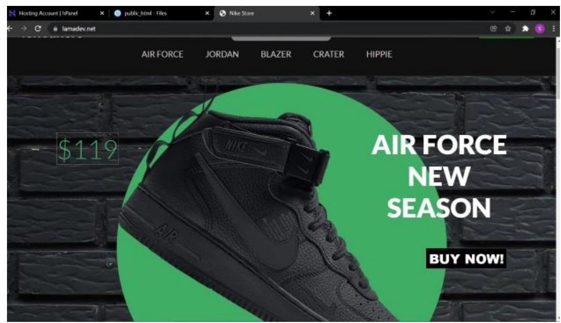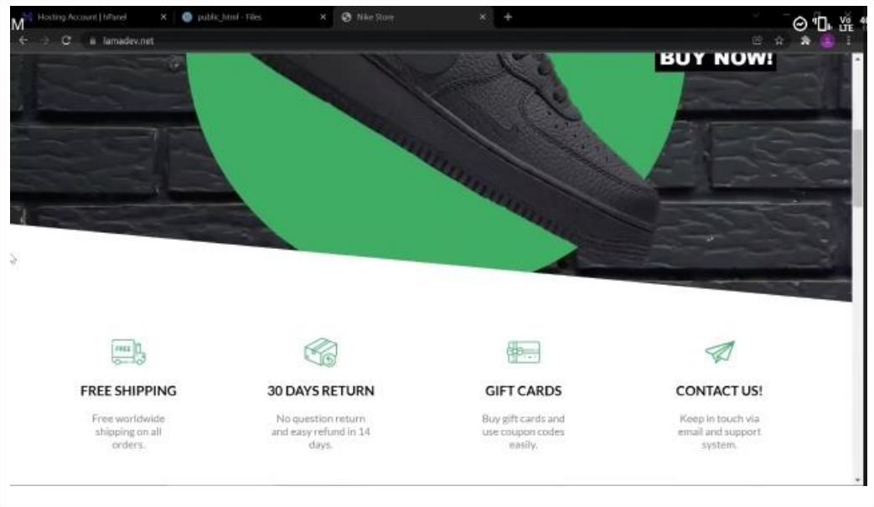

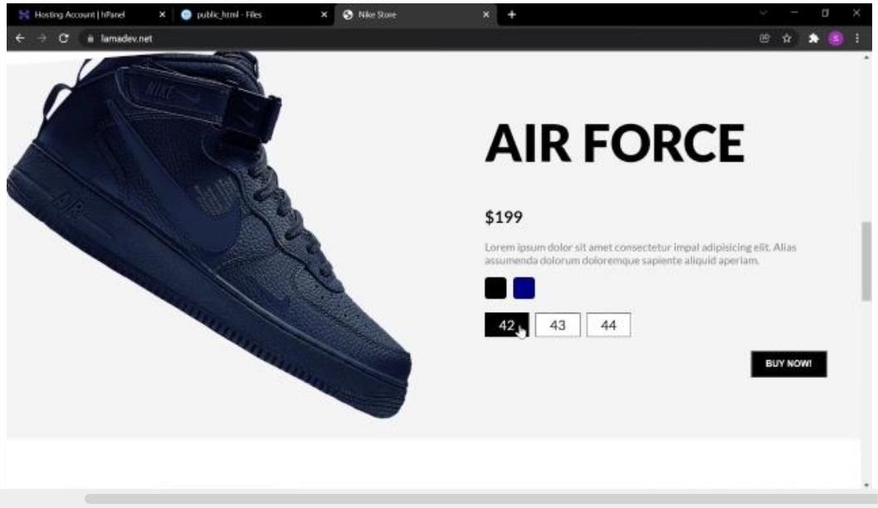

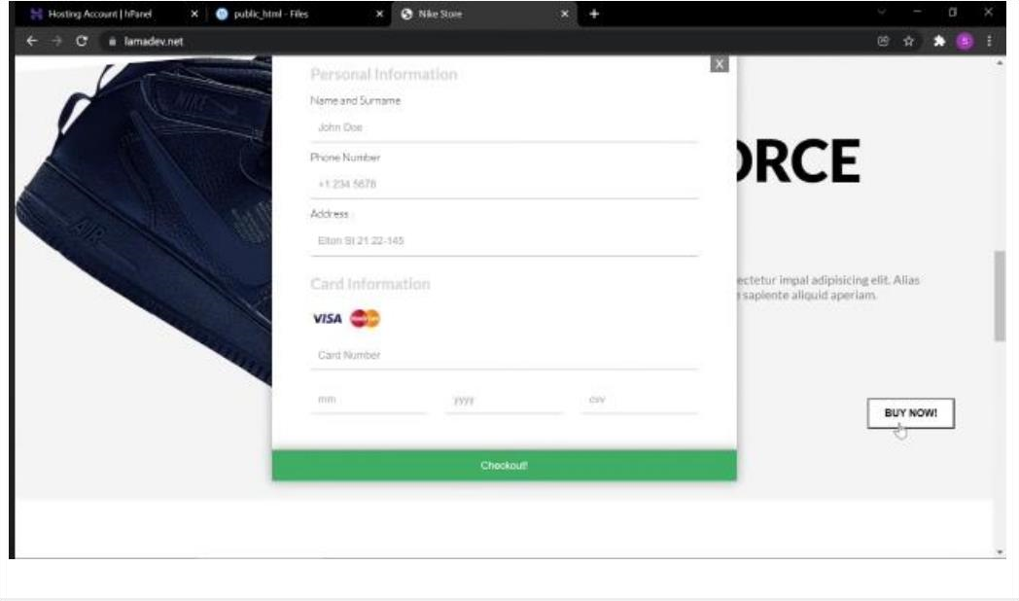

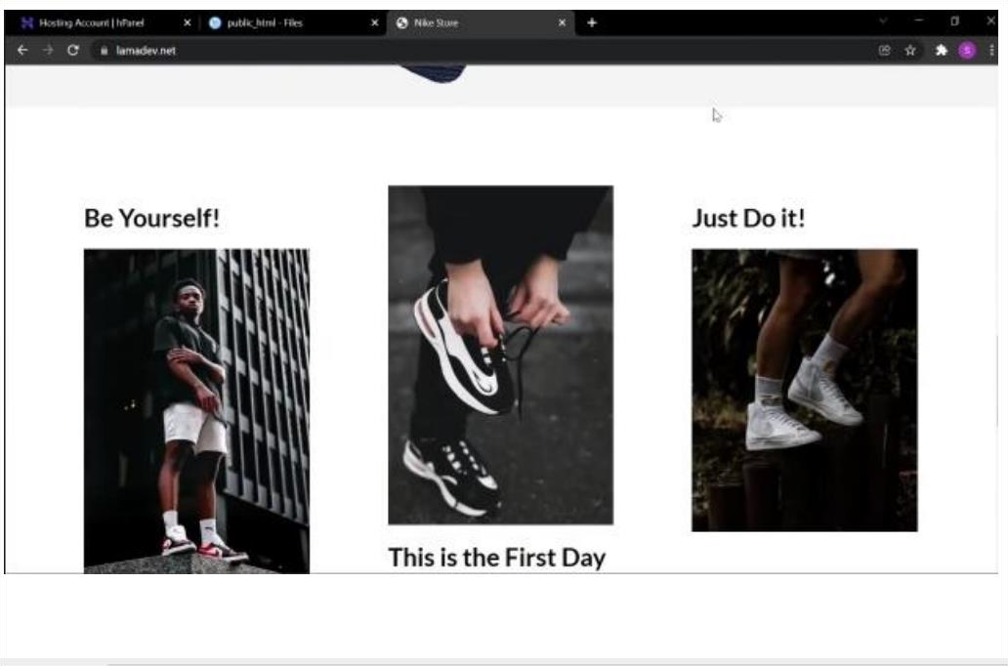

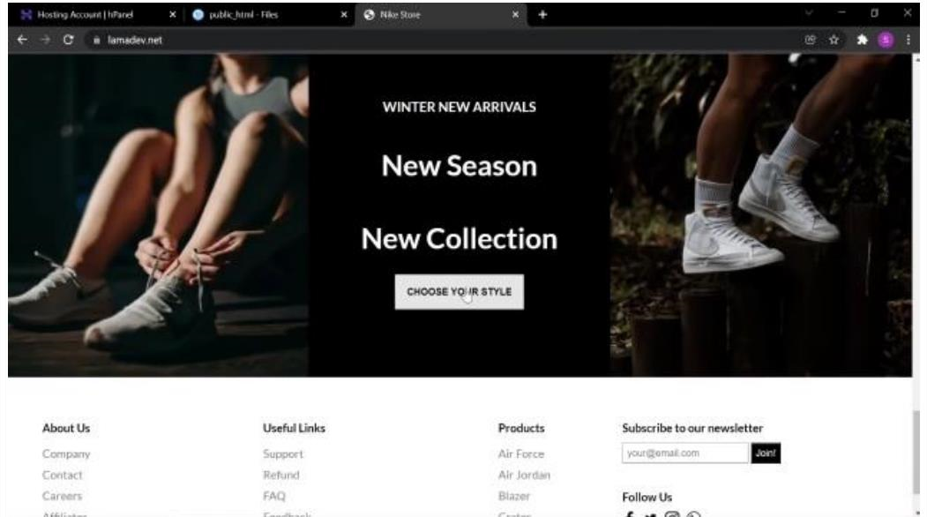

**CHAPTER 9:**

**ANNEXURES**

**CHAPTER 10:**

**Mentor: Abhishek R**

Authorized Signature

:

Prinston Smart Engineers



# INTERNSHIP ATTENDANCE CERTIFICATE

This is to certify that **shoaib**has successfully completed an internship program at our company During this period, they demonstrated commendable dedication and enthusiasm towards their assigned tasks and responsibilities. They actively participated in various projects and initiatives, contributing positively to the team’s objectives.

This certificate is awarded in recognition of commitment and valuable contribution to our company.

**CHAPTER 11:**

## LOGSHEET

Name of Student**: shoaib**

Name of Organisation**: PRINSTON SMART ENGINEERS**

DATE

TOPIC

|  |  |  |  |
| --- | --- | --- | --- |
| DATE | TOPIC |  | CONTENTS |
| 01/04/2024 | Introduction | •  • | HTML  CSS |
|  |  | • | JS |
|  |  | • | PHP |
|  |  | • | MySQL |
| 02/04/2024 | HTML | • | Introduction |
|  |  | • | Tags |
|  |  | • | Elements |
| 03/04/2024 | HTML | •  • | Images  Figure Caption |
| 04/04/2024 | HTML | • | Linking pages |
| 05/04/2024 | HTML | • | Implementing Lists |
| 06/04/2024 | HTML | • | Creating simple HTML page |
| 08/04/2024 | FORMS | • | Introduction |
|  |  | • | Basics |
|  |  | • | Field set |
|  |  | • | Elements |
| 11/04/2024 | FORMS | • | Using iframe |
|  |  | • | Audio |
|  |  | • | Video |
| 12/04/2024 | FORMS | • | Creating a form page |
| 13/04/2024 | CSS | • | Introduction to CSS |
|  |  | • | Types of CSS styling |
| 15/04/2024 | CSS | • | Tags used <div> <span> |
|  |  | • | Selectors |

40

|  |  |  |  |
| --- | --- | --- | --- |
| 16/04/2024 | CSS | • | CSS colour properties |
|  |  | • | Background colour |
| 18/04/2024 | CSS | • | CSS border styling |
|  |  | • | Box and text shadow |
| 19/04/2024 | CSS | • | Text properties and font properties |
| 20/04/2024 | CSS | • | Font properties |
|  |  | • | Positioning |
| 22/04/2024 | CSS | • | Using CSS for simple page |
| 23/04/2024 | CSS | • | Creating a home page using  CSS |
| 24/04/2024 | JavaScript | • | Introduction to JavaScript |
|  |  | • | Variables |
| 25/04/2024 | JavaScript | • | Datatypes |
|  |  | • | Arrays |
| 26/04/2024 | JavaScript | • | Conditions |
| 27/04/2024 | JavaScript | • | Using statements |
| 29/04/2024 | JavaScript | • | Creating a page with HTML, CSS and JavaScript |
| 30/04/2024 | PHP | • | Installation of XAMPP |
| 02/05/2024 | PHP | • | Introduction to PHP |
|  |  | • | Variables |
| 03/05/2024 | PHP | • | Conditions used in PHP |
| 04/05/2024 | PHP | • | Functions |
|  |  | • | Array |
| 06/05/2024 | PHP | • | Connecting PHP |
| 07/05/2024 | MYSQL | • | Introduction to MYSQL |
| 08/05/2024 | MYSQL | • | Datatypes |
|  |  | • | Attributes |

41

|  |  |  |  |  |
| --- | --- | --- | --- | --- |
|  | 09/25/2024 | MYSQL | * Attributes * Constraints |  |
| |  | | --- | | 10/05/2024 | | |  | | --- | | MYSQL | | • Creating Database using  MYSQL |
| |  | | --- | | 11/05/2024 | | 13/05/2024 | | 14/05/2024 | | 15/05/2024 | | 16/05/2024 | | 17/05/2024 |                 Authorized Signature: | | |  | | --- | | PROJECT | | PROJECT | | PROJECT | | REPORT | | REPORT | | REPORT |   42 | |  |  | | --- | --- | | • | Working on project | | • | Working on project | | • | Implementation of project | | • | Working on report | | • | Working on report | | • | Working on report | | |

**CHAPTER 11:**

**BIBILOGRAPHY**

•

[m](http://www.youtube.com/)

[www.youtube.co](http://www.youtube.com/)

•

Freeman, A,

& Robson, J. (2018). Head First HTML and CSS: A Learner's Guide to

Creating

Standards

-

Based Web Pages. O'Reilly Media.

•

https://stackoverflow.com

•

W3Schools

-

https://www.w3schools.com

43

**CONCLUSION**

T

his internship has been an invaluable experience that has significantly contributed to both my personal and

professional growth.

Throughout this period, I acquired extensive knowledge and honed my technical skills,

particularly in web development and database management. Understanding HTML, which is a fundamental

component of web applications and one of the most popular languages fo

r web design used by professionals

worldwide, has been a crucial aspect of my learning journey. HTML, alongside CSS, forms the backbone of

millions of websites, demonstrating its pervasive role in the digital landscape.

This internship provided me with the

opportunity to explore the vast capabilities of these technologies, and

I realized that my ability to learn and adapt is greater than I had initially anticipated. Self

-

learning became a

key component of my growth, empowering me to independently acquire ne

w skills and knowledge.

Moreover, this experience has illuminated the immense opportunities available for those aspiring to work in

the field of web development. The demand for web development professionals is on the rise, driven by the

continuous expansio

n of digital platforms and the need for innovative web solutions. This growing demand

translates into significant job opportunities for individuals equipped with the necessary skills and expertise.

In addition to web development, my exposure to MySQL has b

een particularly enriching. Overall, this

internship has been a remarkable journey of discovery and learning. It has not only solidified my technical

competencies but also boosted my confidence in my ability to pursue a career in web development. The

knowl

edge and skills I have gained will undoubtedly serve as a strong foundation for my future endeavours

in this dynamic and ever

-

evolving field.

44